**Letter from me to yall**

Hey guys, I just wanted to start off by saying that while this project may be

tough and difficult for you guys, I truly believe it'll be a good learning experience

for yall and will teach you guys good skills to use in future projects.

Very rarely will you have someone with years of experience guide you throughout

your careers and school work, so please feel free to ask me whatever you guys need.

I may not always give straightforward answers, but I'm always going to do my best to

help lead you guys in a way that'll be better for your future!

It's also worth noting that I'm not in any way smarter than you guys, while I may

have 1-2 years of coding experience above you guys, you guys have more potential to grow

and learn more than I ever could've in your age. All it takes is a lil grinding along the way.

Just know I believe in you guys and promise this will be worth it in the end!

Okay, onto the readme. For this template, my goal is to teach you guys how a basic

webpage works, utilizing HTML, CSS, and Javascript. No Python just yet.

*I am writing this guide using a windows PC by the way, however it should be similar to using MacOS as well*

**DOWNLOAD FOLDERS**

In order to download the files, first open up VSCode and open up a terminal

(at top click terminal->new terminal)

Next cd into the folder you want this code in(if not already in)

Now type into the command “git clone <https://github.com/Dannyle1237/MedicalAnalysis>” without the “

This should automatically download the files into the folder your terminal is pointing to

**RUN FILES**

There are two main ways to get an html webpage running. I suggest using the 2nd method btw

First.)

1. Open your web browser(preferable google chrome or firefox)

2.) Simply drag the html file into the browser tab sections, such as the image below

This method works fine, however if you are making changes to your webpage while viewing it, you must constantly redrag your file into the browser.

Second.)  
 You can also download an extension to do this for you

1. In VSCode, click on the extensions tab on the left
2. Search up Live Server
3. Install Live Server

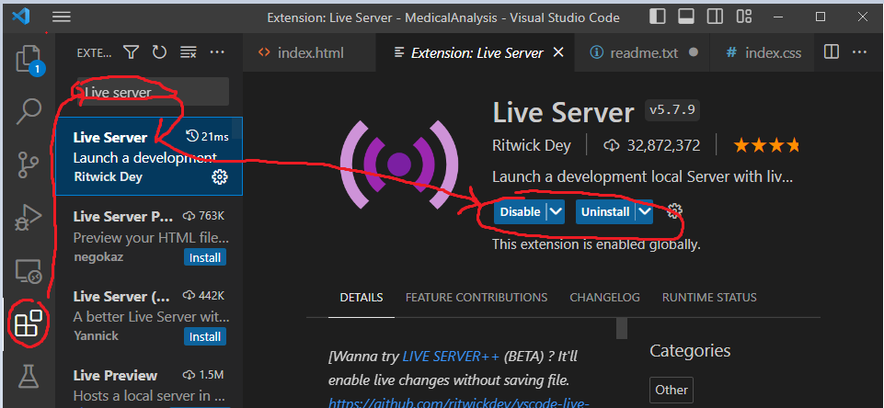

1. Once installed, you may need to restart vscode to see it but you should now see a button at the bottom of the app that says “Go Live” when looking into your HTML file. Once you click it, it should pop up a webpage with the app on it

1. If a webpage doesn’t show up, just type into your browser

localhost:<Port Number>

1. Graphical user interface, application

   Description automatically generated

If you get something like this, just click on the folder until you reach the webpage!

I like this method more because live server automatically updates the changes for you.

Now when you click start, a timer should start keeping track of seconds and minutes the program has been running for (Roughly, I didn’t actually calculate the time).

And there you have it, you have a working web application.

**UNDERSTANDING FILES**

When it comes to developing a webpage, the 3 core basics will be an html, css, and js file.

The HTML file is essentially the skeleton of your page, it’s where you layout your elements and organize where everything goes.

The CSS file is how you style and design your webpage.

The JS file is how you add programming to a webpage.

Looking at the HTML file, you can see how I laid out stuff to get the webpage going

Here are some basic tags and their definition

title: Name of webpage (not rly important atm)

body: Where essentially all of your core elements will go

div: Container for your elements

h1: Header text (You can also have h2,h3,h4…)

p: Basic text

button: Just a button. Functionality is implemented through JS

id: A label for the element, which you can later use to identify it in JS. Should be unique

class: Another label for an element, except you can use it for multiple

script: This is the tag that will import programming into your webpage. It is always put at the end of the body tag

Looking at the CSS file

I forgot to mention to connect the css file to the html file, you have to include a line to link the stylesheet, as highlighted in the picture!

Here, we use css to change the style of certain elements on our html page.

For example, I made the start button to have a larger width and height than it’s original parameters, and aligned the text in the div to be centered.

Feel free to mess with these and see how the changes are. Remember you must save your file to see changes and if you are not using a live server, you must redrag the html file into your browser.

Looking at the JS file

In this file, I left a lot of comments to help yall understand it better, but ill also leave some pictures here to help connect the picture on how HTML and JS are connected.

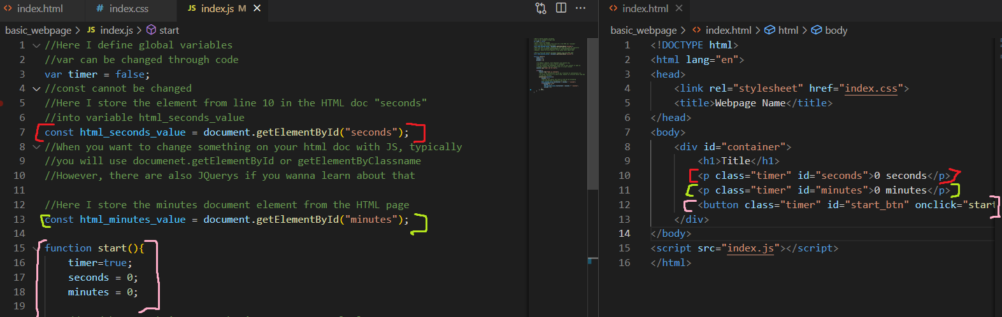

The main things to take away

How to grab the elements from the HTML page into the JS code

How to implement a function into the button!

And that’s really all I have to tell you guys, if you have any questions please DM me on Discord

Grauis#6634

Or even text my phone number

2145542498

Now my challenge for you guys is

1. Add a new line of text below the minutes one that keeps track of hours
2. Add a new button that will stop the timer